**M S Ramaiah Institute of Technology**

(An Autonomous Institute, Affiliated to VTU)

MSR Nagar, MSRIT post, Bangalore-54.

A **Project Plan** for

**BUILDING A WEB SERVICE FRAMEWORK (STOW-RS) FOR MEDICAL IMAGING**

Submitted By:

**NEHA PATHAPATI**

**(USN:** 1MS12CS143)

**COMPANY:** PHILIPS

**BUSINESS UNIT:** HEALTH SYSTEMS

*in partial fulfillment for the award of the degree of*

# *Bachelor of Engineering in Computer Science & Engineering*



**DEPARTMENT OF COMPUTER SCIENCE & ENGINEERING**

**M.S.RAMAIAH INSTITUTE OF TECHNOLOGY**

**(Autonomous Institute, Affiliated to VTU)**

**BANGALORE-560054**

[www.msrit.edu](http://www.msrit.edu), **Feb 2016**

**PROJECT PLAN**

**PROCESS MODEL**

**Scaled Agile Framework** (SAFe) is the process model which will be followed in the project execution.

The Scaled Agile Framework provides a recipe for adopting the Agile model at an enterprise scale. It helps organizations to scale agile from the team to the program to the portfolio level.

The PORTFOLIO LEVEL comprises of the highest and most strategic layer where programs are aligned to the company's business strategy and investment approach.

At the PROGRAM LEVEL,

* SAFe uses the concept of an Agile Release Train (ART) or Train to deliver the expected value.
* An ART can also be called a Program Increment (PI), and spans for a period of 3 months.
* It is the primary vehicle for value delivery at the program level.
* A Release Planning Meeting (RPM) is conducted on the first three days of each PI.

It helps to draw up the work to be done in the next 3 months.

* RPM is a form of collaborative, deliberate discovery workshop to determine the initial set of User Stories that will be worked on by the teams. These User Stories are then prioritized into releases.
* Additionally, the tasks undertaken in a RPM include – assigning story points (amount of effort required, can be 1,3,5,7,11,13,15, or 20, indicating 1 hour, 2 hour, etc.) to individual user stories, and determining - the features that will be delivered, the risks involved, the internal dependencies, the external dependencies, the defects, the technical/architectural debts, and the spikes (user stories involving a high degree of uncertainty).
* All the user stories are then wisely distributed into sprints (10 working days – 2 week periods).
* Between 5 and 10 teams work together on a train to deliver business value.
* Every 10 weeks (5 iterations) a train delivers a Potentially Shippable Increment (PSI). A release demo, inspection, and adaptation sessions are conducted.
* After successful delivery of a PSI, planning for the next PSI commences.
* PSIs provide a steady cadence (flow) for the development cycle.
* In SAFe the actual market release is often separated from this cadence. This allows product management to decide when the actual market releases are based on business timing rather than development cycles.

At the TEAM LEVEL,

* SAFE uses a hybrid of Scrum and XP engineering practices.
* All teams operate on the same cadence, i.e. the sprint duration is the same across all teams.
* The teams synchronize their sprint start and end dates for better co-ordination between teams.
* Potentially Shippable Increments (PSI) of a product will only be possible after a number of sprints are completed.
* Define/Build/Test (DBT) teams deliver working, fully tested software every two weeks. There are five to nine members of each team.
* Time is divided into a set of fix length sprints (or iterations) of duration 2 weeks.
* At the start of each sprint, a sprint planning is done. Here, the team members review the user stories assigned to various sprints in the RPM and commit to the user stories they will execute.

**RISK IDENTIFICATION AND RISK MITIGATION STEPS**

The top 5 risks of our project and their mitigation steps are enlisted below:

|  |  |  |
| --- | --- | --- |
| **Sl. No** | **RISK** | **RISK MITIGATION** |
| **1.** | Difficulties which may arise in the integration of the multiple STOW layers. | To employ the practice of Continuous Integration. This ensures that the teams are able to produce the required value: the team increment. The team should integrate and test its work at least once in a PI. To emphasize on the importance of Continuous Integration, there should be a user story and story points dedicated to integration in the RPM, just like for the other development activities. |
| **2.** | Lack of expertise with new technologies leading to decelerated execution of tasks. | Training sessions have to be conducted to increase the proficiency of team members with the new technologies being used like HP Fortify Scan. Also, always available online/offline help must be arranged. |
| **3.** | Evolving design of STOW – RS service. | Create user stories to accommodate design improvements/modifications, their implementation, and their testing in all sprints. Brainstorming is also an effective strategy. |
| **4.** | Maintaining security. | A foolproof mechanism to authenticate and authorize the third party client posting DICOM instances using the STOW – RS service. |
| **5.** | Finally, the possibility of risks not being identified and mitigated at the appropriate levels is itself a massive risk! Also, the tasks of risk mitigations should be explicitly assigned to project team members to assign responsibility. | Code level risks must be resolved at the team level. Risks that may affect the entire Agile Release Train (ART) should be dealt with at the program level. This prevents the same risk from being encountered twice or getting escalated.  ROAM board is an efficient tool to mitigate this risk. It must be used during PI planning to identify and analyze risks and issues. To make sure all the risks are covered, the goal of this technique is to Resolve, Own, Accept or Mitigate all risks (ROAM).  Hence, potential issues at the Team-level ROAM board don’t get transferred onto the Program-level ROAM board. Also, the ROAM tool ensures that all risks are covered i.e. after a ROAM session, responsibility is assigned to solve these issues. |

**PROJECT SCHEDULE**

The schedule of the project is as follows**:**

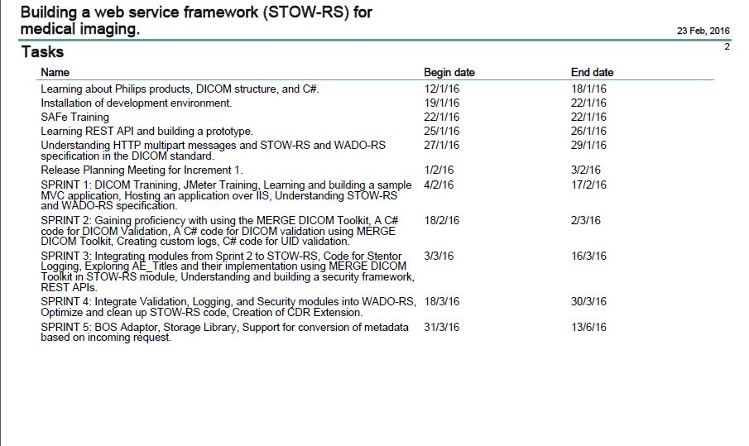

The schedule of the project is depicted using the Gantt Chart below:

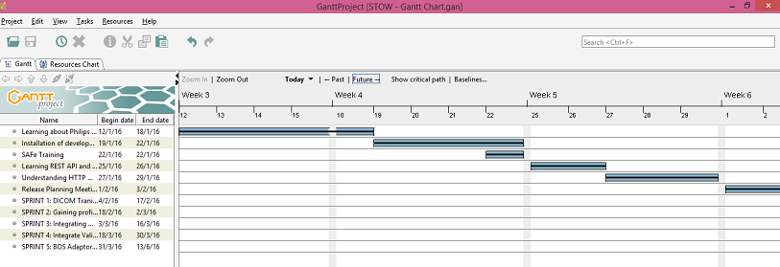

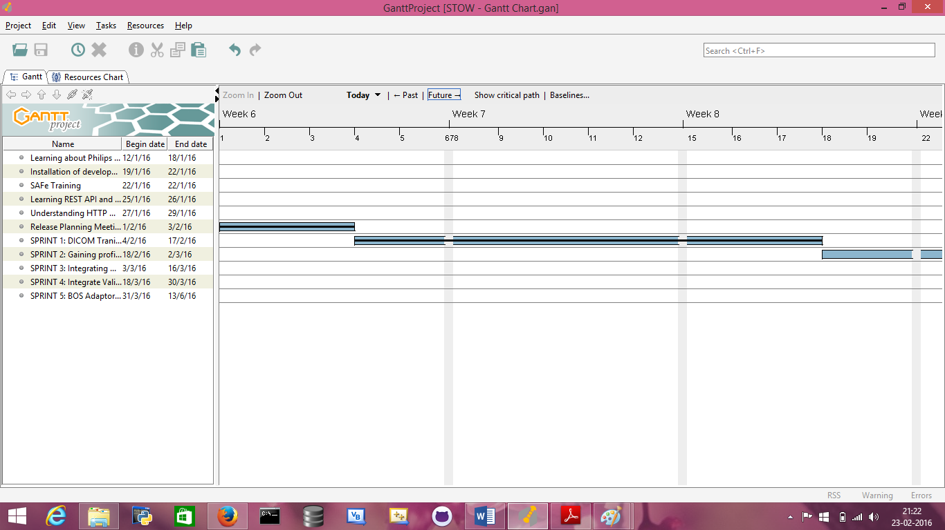

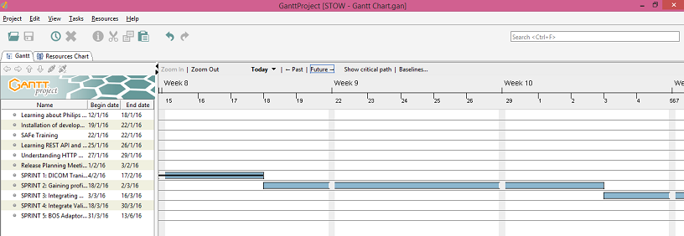

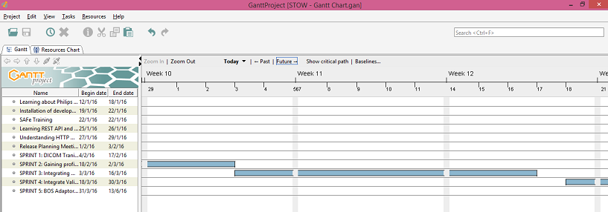

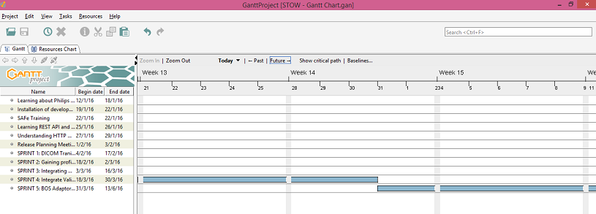

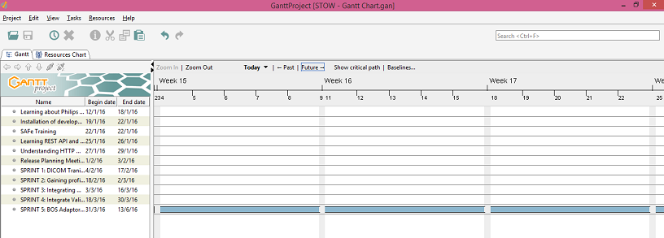

The project will reach completion by June 14th. Since the Scaled Agile model is employed, the subsequent tasks to be undertaken will be determined in the RPM of the next PI.